**P615/1**

**ART**

**(Drawing or Painting**

**From Still life and Nature)**

**Paper 1**

**Jul/Aug 2019**

3 hours

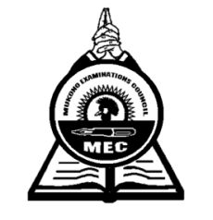

**MUKONO EXAMINATION COUNCIL**

**Uganda Advanced Certificate of Education**

**ART**

**DRAWING OR PAINTING FROM STILL LIFE AND NATURE**

**Paper 1**

**3 hours**

**Note:***Candidates must be instructed that* ***ruling*** *by all means whatsoever is* ***forbidden*** *except when marking off space for name and other particulars.*

This paper offers two major alternatives A and B. Candidates may attempt either A or B but not both

**ALTERNATIVE A:** Drawing or painting from Still life.

Candidates must be instructed that ruling by any means whatsoever is strictly forbidden

**ALTERNATIVE B:** Drawing or painting from Nature.

Candidates are required to make a study or studies, using any side of the sheet of paper.

**Either**

**Alternative A: STILL LIFE**

On a raised platform, place a round rolling board and on it put a kilo of fresh meat showing bit of chopped ribs in a heap. To the left slightly behind, put a 3 litre jerry-can of “Fortune” cooking oil at angle with its lid intact and the handle facing the candidates to the left side. In front of the rolling board diagonally place a new knife whose handle touches the floor with end resting on the meat. In front of the whole setting, slightly to the right side place one large tomato, large onion and a large egg plant (Biringanya) clearly seen by the candidates.

**Or**

**Alternative B: NATURE STUDY**

1. Candidates draw or paint a landscape in which a building is at angle on a raised ground with trees in the background.
2. Make a study of a fresh creeping plant with fairly large leaves approx. 60cm long, coiled around a dry branch standing vertically.

***End -***